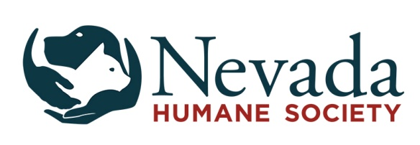
Pet Food Assistance Program

Nevada Humane Society’s Pet Food Assistance program provides pet food to individuals and families under the following three circumstances:
- One Time Assistance For individuals or families who are experiencing a sudden/unexpected financial hardship and cannot afford to purchase food for their pets.
- Temporary Assistance for individuals or families who are experiencing temporary financial hardship and cannot afford to purchase food for their pets.
- Long-Term Assistance may, on a case-by-case basis, be made available to individuals who are disabled, on public assistance, or meet specific other criteria and are unable to afford to purchase pet food.
- Feral Cat Colony Caregivers are eligible to receive food for their cat colonies. NHS has temporarily suspended our Trap-Neuter-Return Program. If you are feeding outdoor cats, please contact 775-856-2000 ext. 337 or TNR@nevadahumanesociety.org and we will contact you when this program resumes.
The program is not intended for those with the financial means to purchase pet food. The purpose of this application process is to prevent abuse of the program by eliminating people who can afford to buy pet food or those who are deliberately breeding animals. It is not to make things difficult for those who are deserving of assistance.
Applying for Assistance
If you feel you may be eligible for assistance under one of the above circumstances, please complete the Pet Food Assistance Application.
If you are applying in person, your application will be given a preliminary review by staff and in most cases, you will be allowed to obtain food today.
Food Distribution Times
Food is distributed two days a week at the following times:
- Wednesdays from 11:00 am – 1:00 pm
- Sundays from 11:00 am - 1:00 pm
If you are unable to make it on one of these days and times, please call 775-856-2000 ext. 302 to see if other arrangements can be made.
Policies:
Eligibility: Only one individual per household is eligible to receive pet food. Recipients must demonstrate financial need.
- Quantity: We strive to provide a one month supply of pet food. Food supplies may be limited and we cannot guarantee that food will be available.
- Duration: Temporary Assistance clients may return once a month, receiving assistance for a three-month period. Long-term Assistance clients and Feral Cat Colony Caregivers may be eligible to receive food for a longer period of time, but will be asked to update their information on file every 3 months.
- Requests: We will consider special requests for certain formulas or flavors of dog food (ie. senior, grain free, etc), but are only able to give what we have at the time the request is made.
- Resale: Pet food obtained through the program is not to be resold by anyone in the household or by any third party. If the pet food is resold, you will be ineligible to receive pet food through the program again.
- Intact pets: We ask for this information, but it will not limit your ability to gain pet food assistance from during the Covid 19 pandemic.
- Feral Cats: If you are feeding feral cats and are picking up food for a colony, please tell us how many cats you are feeding.
- Confidentiality: We ask for personal information on the application. This information is kept in the strictest confidence and is not shared with any other individual or any other agency.
- Denial and Exceptions: NHS reserves the right to make exceptions based on individual need, to require proof of spay/neuter, and to refuse anyone under any circumstance at any time.
- Liability Release: By accepting food, the recipient and all household members agree to release, discharge, indemnify, and hold harmless Nevada Humane Society and its staff, volunteers, and benefactors in the event that the recipient's pet(s) becomes ill or develop an upset stomach.

Please complete the Pet Food Assistance Application and turn it in upon your visit to pick up Pet Food Assistance at Nevada Humane Society, 2825 Longley Lane, Reno, NV 89502 or our Carson City shelter at 549 Airport Road, Carson City, NV 89701.
If you have any questions please call us at: 775-856-2000 ext.301.

